Ideation Phase

Brainstorm & Idea Prioritization
Date | 08 July 2026
Team ID | SWTID-2026-3267
Project Name | SB Stocks
Maximum Marks | 4 Marks

Brainstorm & Idea Prioritization
During brainstorming, the team identified common challenges faced by beginners in stock trading, including financial risk, lack of practical experience, and limited access to market simulation. The team evaluated several ideas and selected SB Stocks because it provides a realistic paper-trading environment using virtual funds, real-time US stock data, portfolio tracking, and watchlists.

Step-1: Team Gathering, Collaboration and Problem Statement
- Conducted a team discussion to identify problems in learning stock trading.
- Compared ideas such as crypto simulator, expense tracker, and paper trading platform.
- Selected the problem: Users need a risk-free platform to practice stock trading before investing real money.
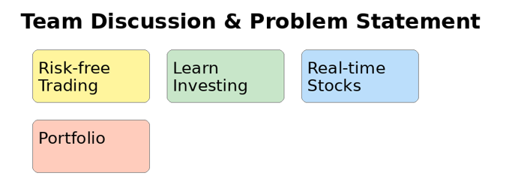

Step-2: Brainstorm, Idea Listing and Grouping
- Paper Trading using Virtual Money
- Real-Time US Stock Listings
- Portfolio Management
- Buy/Sell Simulation
- Watchlist Management
- Interactive Charts & Analytics
- Admin Stock Management
- Secure JWT Authentication
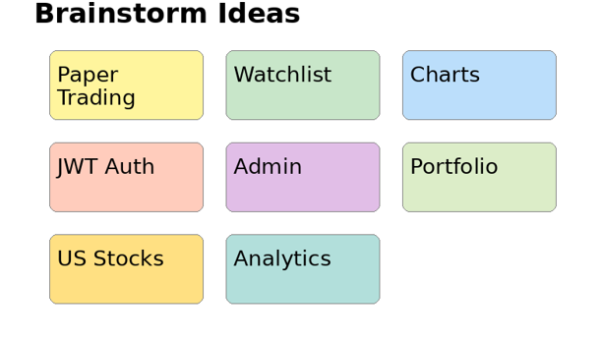

Step-3: Idea Prioritization
After evaluating innovation, feasibility, scalability, and user impact, the team prioritized the Paper Trading Platform (SB Stocks). It provides educational value, realistic trading experience, high scalability with the MERN stack, and can later integrate live brokerage APIs.
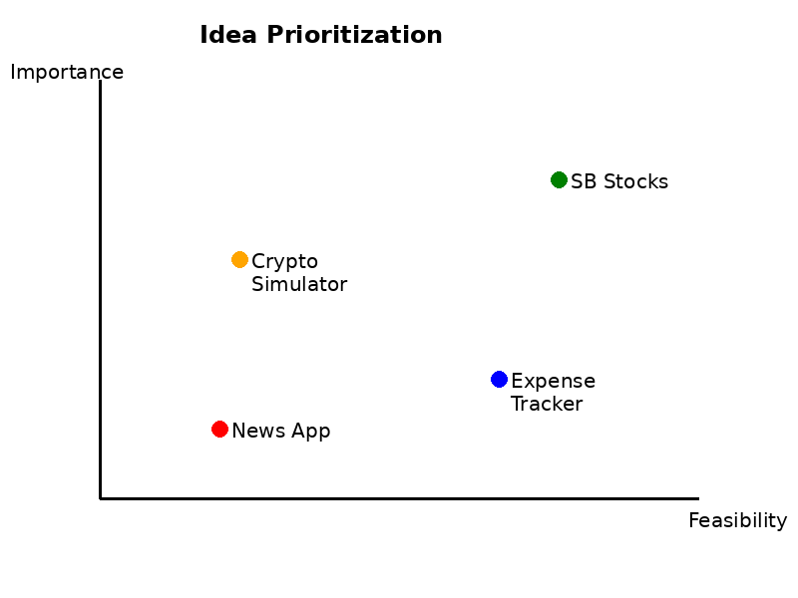

Final Selected Idea
Project: SB Stocks – Paper Trading Simulation Platform
Reason: Provides a safe, realistic, and scalable stock trading practice platform with modern MERN architecture.

